Accessibility Camp Coeur d’Alene Event Program

EVENT AT A GLANCE

Table of Contents

Accessibility Camp Coeur d’Alene Event Program 0

EVENT AT A GLANCE 2

WELCOME MESSAGE 4

SCHEDULE 5

Tuesday, August 1, 2023 5

Wednesday, August 2, 2023 6

ISU After Hours Networking Event 7

Thursday, August 3, 2023 9

5:30 PM Irie-AT After Hours Networking Event 10

SPEAKERS 12

Sal Cano 12

Dax Castro 12

Chad Chelius 14

Joe Devon 15

Chris Gaulin 16

Leslie Gwartney 17

Hayden Kristal 18

Mark Leeper 19

Erin Lucas 20

Karina Mason-Rorris 21

Cody Mitchell 22

Christa Peters 22

Myles Pilling 23

Dan Prado 24

Joshua Quiroz 25

Ryan Scott 26

Jeremy Seda 27

Jackie Stallings 28

Amy Taylor 29

ACCESSIBILITY INFORMATION 30

TACTILE MAPS OF THE VENUE 30

ALTERNATIVE FORMATS 30

https://www.nic.edu/a11ycampfiles 30

ASSISTIVE LISTENING DEVICES 30

WRITTEN DESCRIPTIONS OF THE EDMINSTER S.U.B. AT N.I.C. 31

DOG RUNS 32

GENERAL INFORMATION 33

Event Guidelines 33

Meeting Areas 33

Timing of Presentations 33

Event Name Badges 33

Event Schedule Changes 34

Wi-Fi Access 34

HONORABLE MENTIONS 35

Supporting Partners 35

A11y Camp CdA Organizers 35

A11y Camp CdA Planning Committee 35

Volunteers 35

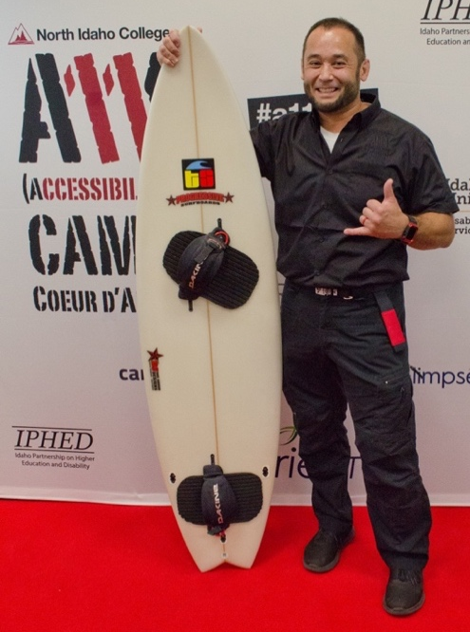
WELCOME MESSAGE
It is with great joy and honor that I extend a warm welcome to each and every one of you at the 3rd Annual Accessibility Camp Coeur d’Alene (A11y Camp CdA)! Drawing from the success of previous camps, we have preserved the best elements while introducing thoughtful upgrades in various areas. Our commitment to delivering excellence is unwavering, and I am confident that A11y Camp CdA 2023 will exceed your expectations.
As you partake in this symposium of speakers and presentations, you will encounter an array of topics centered around accessibility and universal design. Just like in 2022, we have structured the event into three tracks: Passion, Specialized, and Technical.
The global reach of this gathering is a testament to our dedication to address worldwide challenges concerning physical and digital access, ensuring the inclusion of individuals with diverse abilities. Our esteemed speakers represent various industries, including higher education, information technology, disability support, accessible technology, advocacy groups, private businesses, and more.
To make this event a resounding success, our event staff and planners have worked tirelessly to ensure seamless organization and thoughtful arrangements. I am proud to assert that A11y Camp CdA stands as a beacon of accessibility and true inclusivity on the NIC Campus.
On behalf of the passionate individuals who have contributed to making A11y Camp CdA possible, I extend a heartfelt welcome to all of you. Our aim is for you to enjoy this event to the fullest, and we eagerly await your feedback to improve future A11y Camps even further. Thank you for gracing us with your presence and becoming a part of this meaningful journey.
With warm regards and anticipation for fruitful interactions,
Jeremy Seda

SCHEDULE
This year, A11y Camp will have sessions in two locations on the second floor of the Edminster Student Union Building. The Lake Coeur d’Alene Room will host the main sessions and Blue Creek will provide breakout sessions.
The schedule is comprised of three tracks to ensure that every level of expertise can glean knowledge from this event:
Passion Session – Great for ALL!
Specialized Session – Deep dive into a specific area or topic of accessibility.
Technical Session – Sessions that take a “how to” approach for a specific accessible outcome.

Tuesday, August 1, 2023
7:30AM - Check-in Table Open.
8 to 9 AM – Breakfast pastries and coffee/tea in the Silver Beach Gallery on the 2nd floor of the Edminster Student Union Building.
Time | Lake Coeur d’Alene Room
9AM to 12 PM | Document Accessibility Testing with NVDA (Part 1) – Dax Castro & Chad Chelius  (Session Description: T-0900-LCDA)  Add to Outlook or Google Calendar
12-1PM | Lunch Provided by NIC
1PM-3PM | Document Accessibility Testing with NVDA (Part 2) – Dax Castro & Chad Chelius

Wednesday, August 2, 2023
7:30AM - Check-in Table Open.
8 to 9 AM – Breakfast pastries and coffee/tea in the Silver Beach Gallery on the 2nd floor of the Edminster Student Union Building.
Time | Lake Coeur d’Alene Room | Blue Creek  Room
9 to 9:45 AM | A11y Camp CdA Intro & The Best Ability – Jeremy Seda  (Session Description: W-0900)  Add to Outlook or Google Calendar | (see Lake Coeur d’Alene Room)
9:45 to 10AM | [15 minute break] | [15 minute break]
10:00 to 10:45 AM | KEYNOTE: Unleashing Your Inner (Accessibility) Superhero!  Erin Lucas  (Session Description: W-1000-P)  Add to Outlook or Google Calendar | (see Lake Coeur d’Alene Room)
10:45 AM to 11:00 AM | [15 minute break] | [15 minute break]
11:00 to 11:45 AM | Change Them and Us into We – Jackie Stallings  (Session Description: W-1100-P)  Add to Outlook or Google Calendar | Creating Swell Form Maps – Jeremy Seda  (Session Description: W-1100-T)  Add to Outlook or Google Calendar
11:45-1:00 PM | Lunch Provided by NIC | (see Lake Coeur d’Alene Room)
1:00-1:45 PM | Document Accessibility Fundamentals – Dax Castro & Chad Chelius  (Session Description: W-1300-T)  Add to Outlook or Google Calendar | (see Lake Coeur d’Alene Room)
1:45-2:00 PM | [15 minute break] | [15 minute break]
2:00-2:45 PM | Empowering People to See Themselves as Better Than They Are – Dan Prado  (Session Description: W-1400-P)  Add to Outlook or Google Calendar | Academic Coaching – Sal Cano & Josh Quiroz  (Session Description: W-1400-S)  Add to Outlook or Google Calendar
2:45-3:00 PM | [15 minute break] | [15 minute break]
3:00-3:45 PM | The Power of Assistive Technology – Myles Pilling (Session Description: W-1500-P)  Add to Outlook or Google Calendar | Where to Start – Amy Taylor  (Session Description: W-1500-S)  Add to Outlook or Google Calendar
3:45-4:00 PM | [15 minute break] | [15 minute break]
4:00-5:00 PM | Comedy Show - Hayden Kristal  (Session Description: W-1600-P)  Add to Outlook or Google | (see Lake Coeur d’Alene Room)
5:00-5:10PM | Day 1 Closing Remarks – Jeremy Seda | (see Lake Coeur d’Alene Room)
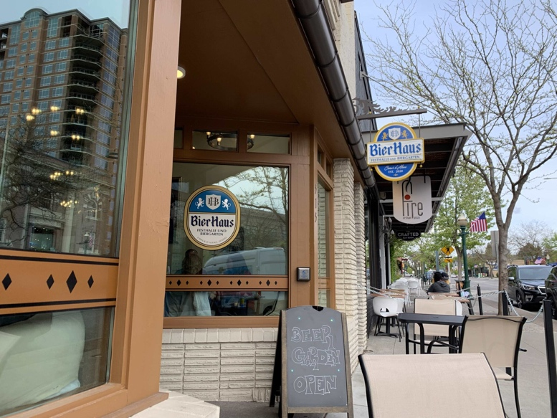
ISU After Hours Networking Event—5:30PM Dinner & “No Host” bar:
Wrist-band (distributed during closing remarks) or conference badge required.
Bier Haus (https://www.bierhauscda.com/)
515 E Sherman Ave
Coeur d'Alene, ID 83814
Menu
(bierhauscda.com/menu/)
Phone: 208-966-4301
Email: prost@bierhauscda.com

Thursday, August 3, 2023
8 to 9AM – Breakfast pastries and coffee/tea in the Silver Beach Gallery on the 2nd floor of the Edminster Student Union Building.
Time | Lake Coeur d’Alene Room | Blue Creek  Room
9:00 to 9:45 AM | Making Live and On-demand Video Accessible – Chris Gaulin  (Session Description: TH-0900-T)  Add to Outlook or Google Calendar | Using Adaptive Technology in Education – Myles Pilling  (Session Description: TH-0900-S)  Add to Outlook or Google Calendar
9:45 to 10:00 AM | [15 minute break] | [15 minute break]
10:00 to 10:45 AM | The Future of Technology Runs Through Technology – Joe Devon  (Session Description: TH-1000-T)  Add to Outlook or Google Calendar | On The Path to Community Accessibility – Mark Leeper  (Session Description: TH-1000-S)  Add to Outlook or Google Calendar
10:45 to 11:00 AM | [15 minute break] | [15 minute break]
11:00 to 11:45 AM | Learning Your Unique Strengths – Karina Mason-Rorris  (Session Description: TH-1100-P)  Add to Outlook or Google Calendar | (see Lake Coeur d’Alene Room)
11:45 AM to 1:00 PM | Lunch Provided by NIC | (see Lake Coeur d’Alene Room)
1:00 to 1:45 PM | Latest Trends in Assistive Technology (AT) – Cody Mitchell  (Session Description: TH-1300-T)  Add to Outlook or Google Calendar | Usability for Low-Vision Users - Beyond WCAG Compliance – Christa Peters  (Session Description: TH-1300-S)  Add to Outlook or Google Calendar
1:45 to 2:00 PM | [15 minute break] | [15 minute break]
2:00 to 2:45 PM | Universal Design and Dyslexia Equals Opportunity – Ryan Scott  (Session Description: TH-1400-S)  Add to Outlook or Google Calendar | Bridging the gap from Word to Accessible PDF – Dax Castro & Chad Chelius  (Session Description: TH-1400-T)  Add to Outlook or Google Calendar
2:45 to 3:00 PM | [15 minute break] | [15 minute break]
3:00 to 3:45 PM | Supporting Students on the Autism Spectrum in Higher Education – Leslie Gwartney  (Session Description: TH-1500-S)  Add to Outlook or Google Calendar | Develop Leadership Skills Through Strengths – Karina Mason-Rorris  (Session Description: TH-1500-P)  Add to Outlook or Google Calendar
3:45 to 4:00 PM | [15 minute break] | [15 minute break]
4:00 to 4:45 PM | Building Neurodivergent Community – Amy Taylor  (Session Description: TH-1600-S)  Add to Outlook or Google Calendar | (see Lake Coeur d’Alene Room)
4:45 to 5:00 PM | Day 2 Closing Remarks – Jeremy Seda | (see Lake Coeur d’Alene Room)
5:30 PM Irie-AT After Hours Networking Event—Pizza & Selkirk Abbey Brewing Company
Wrist-band (distributed during closing remarks) or conference badge required.

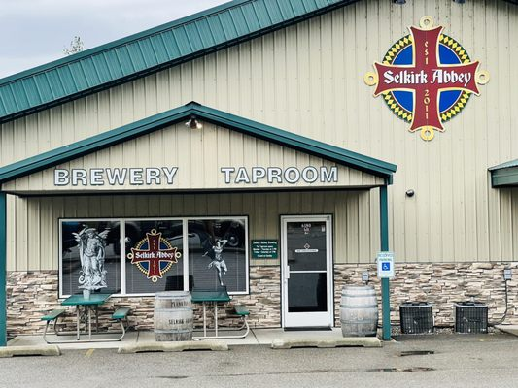
Selkirk Abbey Brewing Company
6180 E Seltice Way, Post Falls, ID 83854
Phone: 208-292-4901

SPEAKERS
Alphabetical order of speakers with session information and supporting materials (if provided):
Sal Cano
Idaho State University
canosalv@isu.edu
Previous Service Coordinator at Idaho State University Disability Services. I recently graduated from Idaho State University's Master of Occupational Therapy program.
Academic Coaching (Session Description: W-1400-S)
An overview of the academic coaching partnerships ISU has developed.

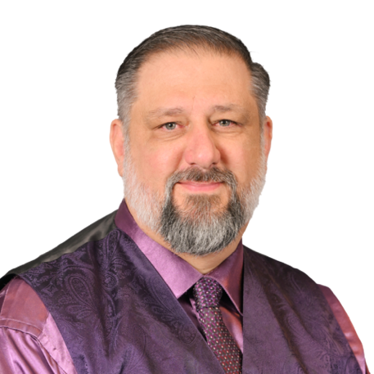
Dax Castro
CHAX Chat Podcast / CHAX Training and Consulting
Email: training@accessibilityunraveled.com
PDF Accessibility Facebook Group:
www.facebook.com/groups/PDFAccessibility/
Youtube: youtube.com/@a11y
website: www.accessibilityUnraveled.com
Dax Castro is an Adobe-Certified PDF Accessibility Trainer who is passionate about creating equitable experiences for people using assistive technology. His specialty is creating beyond-compliant, immersive, and independent user experiences for complex infographics and interactive elements.
Document Accessibility Testing with NVDA (Session Description: T-0900-LCDA)
Testing PDF documents with a screen reader like NVDA is a great way to evaluate the expected user experience and uncover possible gaps in presentation. But using a screen reader can be daunting at first. This class focuses on the tools you need to know and the testing methods that will efficiently evaluate key metrics in your document for usability. Students leave the class with screen reader shortcuts and a 3-page checklist for evaluating a document usability and compliance.
Bridging the gap from Word to Accessible PDF (Session Description: TH-1400-T)
In this session, we will cover foundational techniques for creating more accessible PDFs from Microsoft Word. We will talk about designing documents with accessibility in mind to avoid extra work in the PDF. We will explore the Microsoft Accessibility Checker and give you key items that require manual checks to ensure accessibility. All attendees will leave with two valuable handouts: Accessibility Checklist for Microsoft Word and 10 Things you can do to improve your document accessibility without being an expert.
Related handouts:
- MS Word Accessibility Checklist (Short URL: bit.ly/3YaOR1T)
- 10 Things you can do to improve accessibility without being
an expert! (Short URL: bit.ly/3OcB2vm)

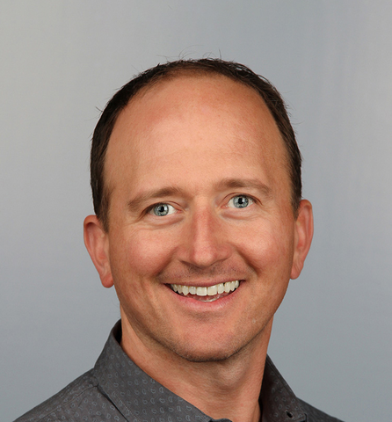
Chad Chelius
Director of Training Solutions and Principal
Chax Training and Consulting
Chad is a speaker, author, trainer and director of training solutions and principal at Chax Training and Consulting. He teaches people how to create accessible documents and how to implement accessibility into their workflows.
Document Accessibility Testing with NVDA (Session Description: T-0900-LCDA)
Testing PDF documents with a screen reader like NVDA is a great way to evaluate the expected user experience and uncover possible gaps in presentation. But using a screen reader can be daunting at first. This class focuses on the tools you need to know and the testing methods that will efficiently evaluate key metrics in your document for usability. Students leave the class with screen reader shortcuts and a 3-page checklist for evaluating a document usability and compliance.
Document Accessibility Fundamentals (Session Description: W-1300-T)
In this session you'll learn what's required for a document to be accessible and you'll learn the fundamental components that are required for a document to be accessible. Learn Acrobat fundamentals and techniques to help you create accessible PDF files.

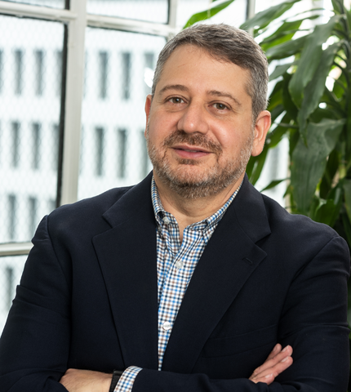
Joe Devon
GAAD Co-Founder / Head of Accessibility, AI Futurist, Formula.Monks
joe.devon@formula.co
@joedevon on all social media
Joe Devon, Head of Accessibility, AI Futurist at Formula Monks, is a technology entrepreneur and web accessibility advocate. He co-founded Global Accessibility Awareness Day (GAAD) and serves as the Chair of the GAAD Foundation, focusing on promoting digital accessibility and inclusive design. Joe also explores AI’s potential to revolutionize digital accessibility, developing AI solutions to enhance online experiences for people with disabilities.

The Future of Technology Runs Through Technology (Session Description: TH-1000-T)
The latest artificial intelligence (AI) hype cycle has led to a rethinking of what innovation looks like. Accessibility is no exception. The Large Language Model's success in 2023 begs a rethinking of not only assistive technology but what disability is anyway. In this presentation, we’ll take you through upcoming developments that will change the world. The exciting part is that accessibility will be at the center of this revolution.

In this presentation you will learn how to:
- Taste vision
- Feel sound
- Smell the future
Our reality will soon be generated by AI, in real-time, in the right format, and personalized to the right person. You won’t want to
miss it!

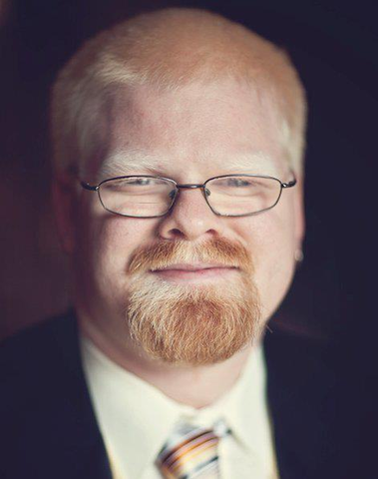
Chris Gaulin
#a11yTO
chris@a11yto.com
Chris Gaulin is a seasoned entrepreneur with over two decades of experience in the digital accessibility space. He regularly brings his experience in digital accessibility, communication technologies, education, and e-learning to government agencies and organizations of all sizes.
Making Live and On-demand Video Accessible (Session Description: TH-0900-T)
With so much more video content being created and so many events being held virtual or hybrid, making video accessible is critical. In this session we will cover the do and don’ts, as well as provide a roadmap from recording preparations, to real-time tips, and finally to post-edit techniques to make your content inclusive.
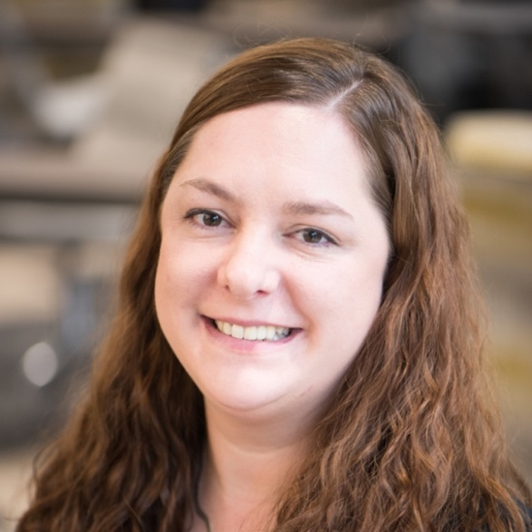
Leslie Gwartney
University of Idaho
ravenscholars@uidaho.edu
Leslie has managed the Raven Scholars program for degree-seeking Neurodivergent student at the University of Idaho since 2016. She has a background in mental health and education. Leslie is passionate about educating others on how to create a supportive, inclusive campus environment to help students of all diversities succeed.
Supporting Students on the Autism Spectrum in Higher Education (Session Description: TH-1500-S | PowerPoint (Short URL: bit.ly/3DuR6Uz)
Learn more about the needs of Neurodivergent students in higher education. Develop awareness and empathy of the barriers for students on the autism spectrum, in addition to tools and strategies to overcome obstacles in higher education.

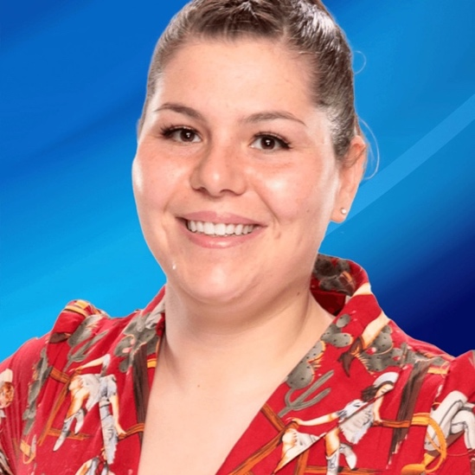
Hayden Kristal
Email: hayden.m.kristal@gmail.com
Hayden Kristal (preferred pronouns they/them/theirs, but accepts anything said with good intent) is a Colorado-based Deaf queer activist and stand-up comedian. They have brought their funny, engaging, and interactive workshops and speeches to dozens of conferences, businesses, and schools all across North America.
Hayden’s quick wit and cheerful self-deprecation has earned them plenty of comedic accolades as well, including over 690,000 followers on TikTok, a semifinalist spot on America's Got Talent, and a guest role on Netflix & Adult Swim’s Tuca and Bertie. Hayden has been a semifinalist for Stand Up NBC and a finalist for Full Frontal with Samantha Bee’s Comedy Writing Mentorship as well.
Hayden Kristal Comedy Show (Session Description: W-1600-P)

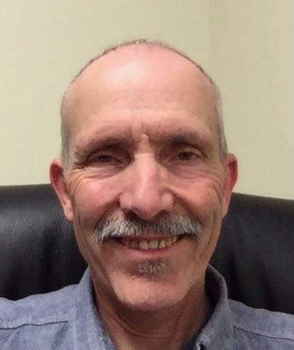
Mark Leeper
Disability Action Center - Northwest
505 N Main St.,
Moscow, ID 83843
www.dacnw.org
dac@dacnw.org
Mark Leeper has been Executive Director of Disability Action Center - NW, Inc. (DAC), a disability run organization since its inception in 1992. He has educated people about accessibility requirements and general disability awareness for over 30 years. Along with managing DAC, his work includes educating about disability access laws and introducing the Blue-Path project, a website designed to build positive relationships with businesses and others to support effective implementation of the ADA. This meshes well with the NW ADA Center – Idaho project Mark manages through DAC that provides technical assistance and training on the ADA.
On The Path to Community Accessibility (Session Description: TH-1000-S)

Erin Lucas
Senior Manager, Accessibility & Website Management, Digital Stores Operations, Microsoft
erinlucas@microsoft.com
Erin currently leads cross-team Accessibility strategic initiatives for Microsoft’s Marketing & Consumer Business Operations Enablement Team. One of her passions is Accessibility evangelism; she loves to help others innovate and advance their Accessibility programs. Her path towards Accessibility leadership began in the DC Metro area ensuring design consistency, usability, and Section 508 compliance for Department of Defense (DoD) software and websites. Prior to coming to Microsoft, she spent five years as the Head of Digital Accessibility at RedShelf, an EdTech start-up in Chicago. She’s an International Association of Accessibility Professionals (IAAP) member, a Department of Homeland Security (DHS) Trusted Tester and a Certified Professional in Web Accessibility (CPWA). In her spare time, Erin enjoys wildlife photography and spends weekends kayaking and boating with her husband Mark and their dog Greta.
Unleashing Your Inner (A11y) Superhero! (Session Description: W-1000-P)
Every good superhero has an origin story! What's yours? What were the pivotal events that unleashed your inner superpower...those a-ha moments where you knew a life of fighting for an accessible world was your calling? During this interactive session we'll talk about my unexpected path to a career in accessibility, share our secret weapons and strategies for battling pesky accessibility villains, and have some fun creating our Accessibility Superhero personas!

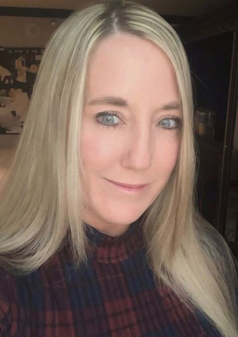
Karina Mason-Rorris
Idaho State University
karinarorris@isu.edu
(208) 282-2294
Alongside her amazing team, Karina Mason Rorris has served as the Director of Disability Services and EIT Coordinator for Idaho State University since 2015 and served as the Assistant Director for two years prior. She has an extensive background in Human Resource Management and Organizational Development as well. Further, she passionate about being a Certified Gallups strengths coach so she may help others understand their strengths. She loves the outdoors; camping, hiking, dirtbike riding, snowmobiling and boating and she adores her blind pug Sir Jaxxon. She is extremely proud of her son, Kody Hensley, who serves as a football coach for ISU. Go Bengals!
Learning Your Unique Strengths (Session Description: TH-1100-P)
Develop Leadership Skills Through Strengths (Session Description: TH-1500-P)

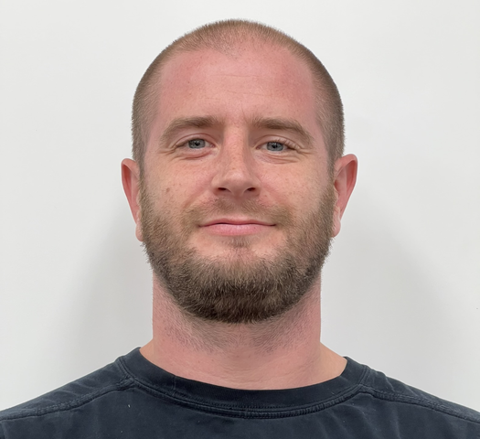
Cody Mitchell
Irie-AT
events@irie-at.com
Cody Mitchell has been training on low vision software and devices since he joined IRIE in 2016. In 2019, he was promoted to Training Manager and now trains industry professionals throughout the nation on the use of braille and low vision devices and accessibility software. Mr. Mitchell is Lead National Trainer for all Irie-AT low vision and braille devices.
Latest Trends in AT (Session Description: TH-1300-T)
Discuss the growth of AT innovations and the integration of AT with mainstream products. This presentation will provide you with an overview of the current state and future directions of AT, as well as inspire you to think about how AT can benefit yourself and others.

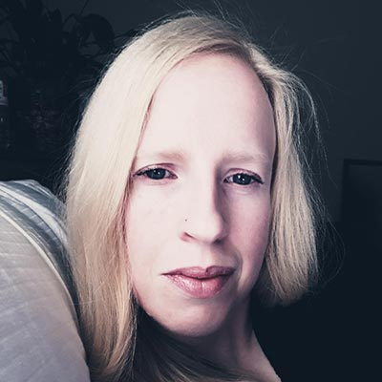
Christa Peters
christa@a11yto.com
Christa Peters is an IT professional based in Charlottetown, PEI. By day, she is a Customer Success Specialist with a growing Canadian SaaS provider. Christa is also an organizer with a11yTO, one of the largest digital accessibility meetup groups globally. She leads the organization’s speaker engagement and provides event logistics to large-scale accessibility events in Toronto and around the world.
Usability for Low-Vision Users - Beyond WCAG Compliance (Session Description: TH-1300-S)
So, your web site checks all the boxes for accessibility – but is it usable? In this session, we will take a candid approach to discussing the top usability issues encountered by low-vision users on web sites and mobile apps.
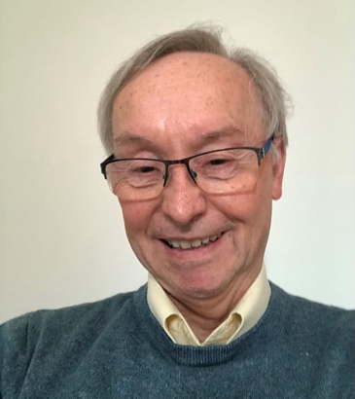
Myles Pilling
Specialist ICT-AT Send Consultant & Assistive Technologist
Twitter: @mylespilling
LinkedIn : http://www.linkedin.com/mylespilling
Facebook: http://facebook.com/accessibility4u
Myles Pilling has been a special school teacher for 28 years and an ICT SEN Advisor for a local authority for 10 yrs. He is a council member of the British Assistive Technology Association. He is considered an Assistive Technology expert in Dyslexia speaking at The Dyslexia Show and for the British Dyslexia Association.
The Power of Assistive Technology (Session Description: W-1500-P)
A year long project to produce 3 short films that demonstrate the Power of Assistive Technology to change lives. Over 25 pupils across 6 schools had in-depth interviews about the journey through education and what they thought about assistive technology. The idea is to use these films as discussion starters in staff meetings, INSET days, Teacher Training promoting the message " Essential for some, Useful for All".
Using Assistive Technology in Education (Session Description: TH-0900-S)
A practical demonstration across different operating systems illustrated by examples of use from "The Power of Assistive Technology. Please bring your devices along to put into practice right away what is being demonstrated. Apps that can make a difference to your students’ lives.
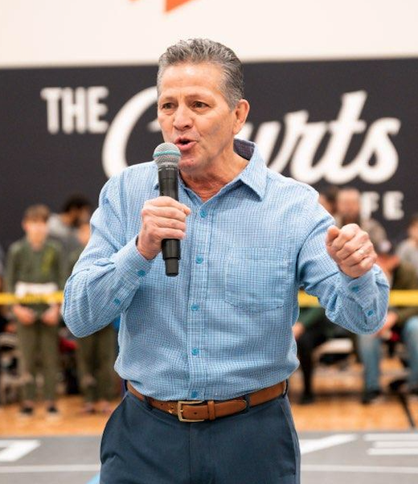
Dan Prado
Corporate & Team Training
danpradoceo@gmail.com
208-610-4219
Dan has spent the last 35 years developing and networking with the finest customers and suppliers in the Machine Tool Industry.
His career started with selling CNC Machinery. This led to Business Development, Strategic Part Sourcing and Equipment Brokering for niche Machine shop and sheet-metal fabricators in the Medical, Aerospace, Semi-Conductor, Oil & Gas, Food Processing, and a variety of other industries. Dan is still heavily involved in this side of the business.
Through these relationships and the encouragement from business owners, Dan was asked to share his great love and passion for Professional Development, Motivational Speaking, and Sales Training.
Since 2007, Dan has had the pleasure of speaking with Professional MMA /UFC fighters, Educational Institutions, Financial Institutions, Real Estate groups, Construction, Home Builders, Restaurants, Manufacturing Companies in the Medical, Motorcycle, Food, and Fishing industries.
Empowering People to See Themselves as Better Than They Are (Session Description: W-1400-P)
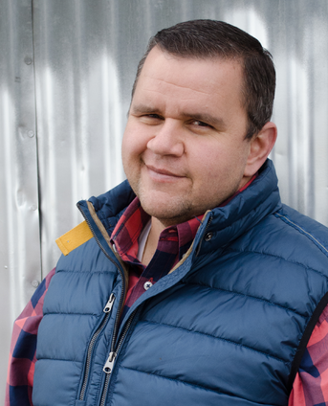
Joshua Quiroz
Idaho State University
quirjosh@isu.edu
I am a Service Specialist for ISU Disability Services. I was born and raised in South East Idaho. I attended ISU, graduating with a bachelors degree and a masters degree in health education. I have a passion to learn and grow as a professional. I also have great desire to serve and help others.
Academic Coaching (Session Description: W-1400-S)
An overview of the academic coaching partnerships ISU has developed.
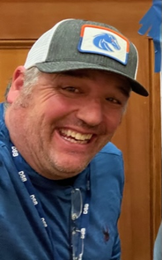
Ryan Scott
rsscott42@gmail.com
I was born two months premature and stayed in the hospital for the first six months of my life. Since this was the early 1970s, a lot wasn't known about the correlation between birth trauma and learning barriers.
When it was discovered I had dyslexia amongst other learning barriers it was decided that I attended one of the first schools in the United States to specifically teach how to manage my dyslexia.
Moving forward, I have successfully earned a Masters’ degree, have worked in higher education for nineteen years, and currently work for the Washington State Department of Services for the Blind.
Universal Design and Dyslexia Equals Opportunity (Session Description: TH-1400-S)
This session describes the journey of incorporating: Universal design, communication skills, and wellness into becoming a successful individual. Not only have these methods worked for me, but after working with other Dyslexics for fifteen years it has also worked for other students within higher education.

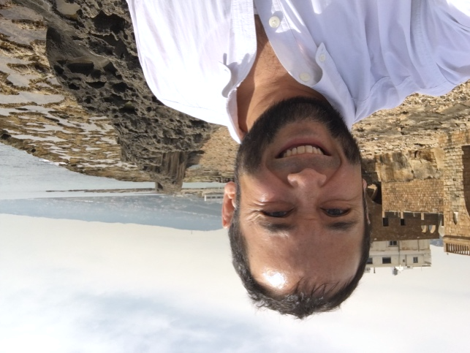
Jeremy Seda
IT Accessibility Coordinator
North Idaho College (NIC)
Jeremy.Seda@nic.edu
Meet Jeremy Seda, the visionary IT Accessibility Coordinator for North Idaho College, where he has been making a profound impact since January 2018.
With a remarkable journey spanning over two decades in the dynamic realms of rich web media and accessible technology, he has continuously evolved to achieve his current milestone.
Jeremy's mission is to humbly build upon the exceptional foundation laid by the EIT Committee and other allies of a11y at NIC. He strives to create a proactive and triumphant model of Universal Design in Idaho Higher Education, embodying his commitment to accessibility and inclusivity.
Beyond his professional achievements, Jeremy finds fulfillment in being a devoted husband and proud father of four. Deeply rooted in his faith as a follower of Jesus, he also embraces diverse passions that shape his character. A Second-degree Professor of Brazilian Jiu-Jitsu, he thrives on the sport's challenges, drawing parallels between his job and his beloved hobby: constant problem-solving, never-ending growth, humility, and a drive to accomplish and learn more. Jeremy is an avid outdoorsman, skilled angler, and hunter.
Join Jeremy on his journey of innovation and progress, where he brings his unique blend of expertise, passion, and unwavering determination to make a lasting impact in the world of IT accessibility.
A11y Camp CdA Intro & The Best Ability (Session Description: W-0900)
A big “welcome back”, an opening prayer, a little event information, and quickly touching upon information from the Passion, Specialized, and Technical tracks of A11y Camp CdA 2023.
Creating Swell Form Maps (Session Description: W-1100-T)
This session covers a quick demonstration of a Picture-in-a-Flash (PIAF) paper and device along with some quick tips for successfully creating tactile graphics. From there, Jeremy will explain the process of how the NIC Tactile Campus Map was created using mapstyle.withgoogle.com and Adobe Illustrator.
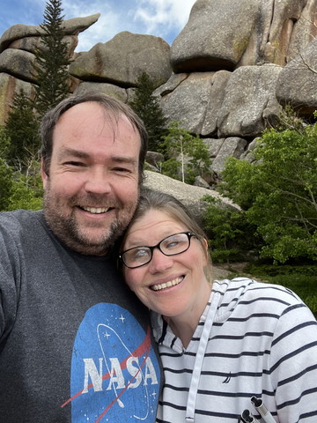
Jackie Stallings
Vocational Rehabilitation Counselor for the Blind, ICBVI
Jackie Stallings is a Vocational Rehabilitation Counselor at the Idaho Commission for the Blind. Legally Blind since birth, she brings personal experience along with professional expertise, to serve her clients in North Idaho. Jackie has a passion for disseminating stereotypes and bringing every day common sense into the accessibility world.
Changing Them and Us into We (Session Description: W-1100-P)
This won’t be your typical conference presentation. Join Jackie as we all have an open and honest conversation about thing people feel nervous to talk about.
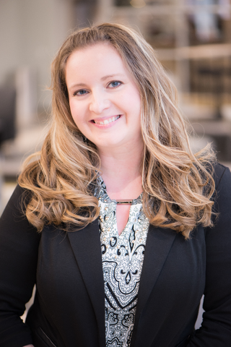
Amy Taylor
Amy.Taylor@nic.edu
208-769-7794
Director of Student Disability, Health and Counseling Services at North Idaho College. She is the President of the Idaho Partnerships in Higher Education and Disability, and former Director of Disability Access and Testing Services at the University of Idaho. Amy brings over 20 years of experience in the field of accessibility including higher education and nonprofit management.
Where to Start (Session Description: W-1500-S)
Common questions we receive as disability service professionals are "how do I refer students to your office?" Often accompanied by, "What if I'm not sure the student has a disability, can I ask?" or "What if a student says they need an accommodation, but I haven't received anything from disability services?" It is important for students to be aware of resources available and to connect students to the appropriate supports and services. This session is to explore terminology, answer common questions, and improve awareness of available resources and everyone's role to meet the diverse needs of our students.
Building Neurodivergent Community (Session Description: TH-1600-S)
Roundtable discussion to explore needs of neurodivergent individuals with the purpose to design structured campus-wide supports for our current and future students.

ACCESSIBILITY INFORMATION
Event accessibility resources can be obtained at the A11y Camp CdA info/check-in table on the second floor, in front of the Lake Coeur d’Alene Room. Only requests made in-advance can be guaranteed; on-site requests are subject to availability.

TACTILE MAPS OF THE VENUE
The Edminster Student Union Building has tactile maps of each floor in the following convenient locations:
- Main Level – off to the right, about 10 steps from the inner automatic doors
- Second Level – Slightly to the left at the top of the stairs, against the railing
- Lower Level – At the bottom of the stairs, along the right-side, against the wall

ALTERNATIVE FORMATS
Session presentation files, Zoom Links, and Outlook & Google Calendar invites are available via the URL:

https://www.nic.edu/a11ycampfiles
Each A11y Camp CdA Session will be provided in-person and in Zoom. Each Zoom meeting will be captioned via 3PlayMedia’s Live Professional Captioning and recorded.

ASSISTIVE LISTENING DEVICES
Assistive Listening Devices are available upon request via the Audio/Video Support Tables in the back of the Lake Coeur d’Alene and Blue Creek Rooms.

WRITTEN DESCRIPTIONS OF THE EDMINSTER S.U.B. AT N.I.C.

ON THE MAIN LEVEL
You enter through the two sets of automatic doors on the East side of the building at the main entrance. This entrance area is tiled floor with a long mat.
You are entering into a two-story open atrium.
Off to the left is a large, carpeted seating area, with a variety of tables and chairs for small groups.
Off to the right is a coffee shop (closed for the summer).
Ahead of you across the room is a cafeteria (closed for the summer).
Next to the coffee shop on your right is a bookstore (open 10-2 on weekdays) – also sells Cardinal gear, beverages, and light snacks.
In the middle of the atrium is a desk with two computers.
Continuing forward/West, off to the right is the Driftwood Bay Room with double glass doors. This room is set up with round tables set with chairs.
To the right of the cafeteria on the West wall is an ATM.
To the left of the cafeteria in the southwest corner of the atrium and to the right of the stairs, is a hallway heading west. The elevators are on the south wall and then in the hallway are restrooms on the left (men, then family, then women) with a drinking fountain on the opposite wall.
On the left, after the seating area, there are stairs going up to the south. The stairs curve to the right to bring you around to the 2nd floor, finishing with a landing and then two steps at the top.

On the 2nd Floor Level:
At the top of the stairs, you will be facing north. Off to the right (or East) are chairs and couches and beyond these on the south wall are Six massage chairs.
The elevator is on the south wall to the left of the stairs followed by men/family/women restrooms the same as on the ground level.
Off to the left you will find a big open space where registration will be.
Standing at the top of the stairs and facing north, the main keynote room is at 11 o’clock about 25 meters from the stairs the Lake Coeur d’Alene Room.
This room is set up with round tables with six chairs to each table.
Straight ahead of you from the stairs is a railing from which you can look out over the ground level.
At 1 o’clock from the stairs is a long hallway. The Blue Creek Room is on the right side of the hallway. It is furnished with round tables set with chairs.

Credit: North Idaho College is extremely grateful to Jackie Stallings and Alison Steven of Idaho Commission for the Blind and Visually Impaired for creating these helpful written descriptions of the Edminster Student Union Building.

DOG RUNS
The large park outside the back of the Edminster Student Union Building (SUB) can be utilized for service animals to relieve themselves. Please be sure to bring any necessary items to responsibly clean-up after your dog.

GENERAL INFORMATION
This program is your road map to all the activities offered at the A11y Camp CdA event. Be sure to familiarize yourself with the contents. If you have any questions, feel free to speak to anyone at the A11y Camp CdA info/check-in table on the second floor, in front of the Lake Coeur d’Alene Room.

Event Guidelines
We strive to ensure the comfort and safety of all participants. We encourage a fragrance-free environment, thus please refrain from wearing excessive fragrances, perfumes and/or cologne during all conference events. North Idaho College is a tobacco-free campus. Cell phones and mobile devices should be turned off or silenced during all presentations. Pease excuse yourself to the hallway or lobby to communicate on your mobile device.

Meeting Areas
Should you need a quieter area to work or conduct virtual meetings, the lower level of the SUB will be available to event attendees. The Powderhorn Bay Room is also available if you need a private option, but is available on a first come, first served basis.

Timing of Presentations
The A11y Camp CdA event is carefully planned on a firm structured schedule. All presentations promptly begin and conclude according to the schedule. Please leave the meeting rooms immediately after each session to allow the next group to enter and start their session on time. Please note: sessions are 45 minutes in length, including Questions and Answers.

Event Name Badges
All registrants, speakers, and volunteers must wear their name badge at all times during the event hours to access the meeting rooms, refreshments and lunches reserved for A11y Camp CdA. Transferring badges to non-registered individuals is prohibited. Thank you in advance for your cooperation and adhering to this policy.

Event Schedule Changes
Last minute changes, additions and cancellations to the schedule can happen. For updates and to confirm session times, visit the A11y Camp CdA event URL at: https://www.nic.edu/a11ycampfiles.

Wi-Fi Access
Connect to the NIC-Public-WIFI network. Once connected, press the “Continue to the Internet” button.
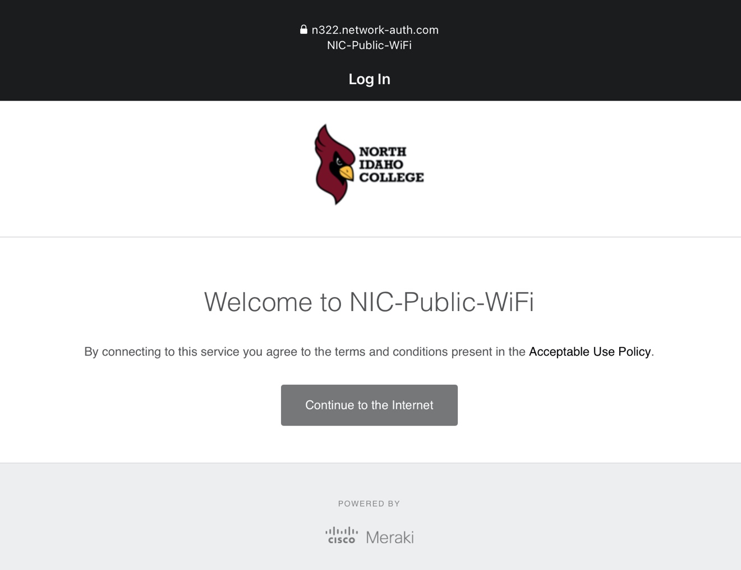

HONORABLE MENTIONS
We express our sincere gratitude and deep appreciation to all our event organizers and supporting partners:

Supporting Partners
- #a11yTO
- American University of Beirut – Accessibility for a Bolder Learning Experience
- Glimpse, L.L.C.
- Idaho Partnership on Higher Education and Disability
- Idaho State University – Disability Services
- Irie-AT
- Microsoft

A11y Camp CdA Organizers
- Bob Gibson – NIC IT
- Melissa Jessen – NIC IT
- Jeremy Seda – NIC IT
- Steve Smith – NIC IT

A11y Camp CdA Planning Committee
- Jeff Gardner – Irie-AT
- Chris Gaulin - #a11yTO
- Robert Gibson – NIC IT
- Melissa Jessen – NIC IT
- Karina Mason-Rorris – IPHED / ISU Disability Support
- Cody Mitchell – Irie-AT
- Christa Peters - #a11yTO
- Jeremy Seda – NIC IT
- Steve Smith – NIC IT
- Dan Smith-Chancey – NIC DSS
- Jackie Stallings – Idaho Commission for the Blind and Visually Impaired
- Amy Taylor – NIC DSS
- Ken Wardinsky – NIC IT

Volunteers
- Alexis Jones
- Jaselyn Jones
- Tejah Jones
- Rachel McRoberts
- Christan Seda
- Dan Smith-Chancey

